Alton Assembly Rooms
High Street, Alton
Hampshire
GU34 1BA

19/03/2026
STAKEHOLDER INVITATION – 29th April 2026
Dear Colleague / Stakeholder
You are warmly invited to attend a presentation of “Waiting Well”, a research study exploring the experiences of people and families waiting for a dementia diagnosis (from Bournemouth University and NIHR ARC Wessex).
The study examines the emotional, practical and social impacts of the diagnostic waiting period, drawing on the perspectives of individuals and families navigating this stage of the dementia pathway. The aim of the session (see Agenda overleaf) is to share key findings and open a conversation with relevant NHS, ICB and social care colleagues about how we can work together to reduce the impact of waiting and better support people during this time.
We would greatly value your perspectives as partners along the Dementia Pathway, in shaping local practical responses to the challenges highlighted in the research. Please feel free to share this invitation with relevant colleagues across health and social care.
We hope you will be able to join us for this important discussion.
Please RSVP to contact below by 27th April – with details of any dietary requirements
Kindest regards
Karen Murrell, Coordinator – Dementia-friendly Alton
07922 022321 / 01420 551455 / karen.murrell@dementia-friendly-alton.org.uk
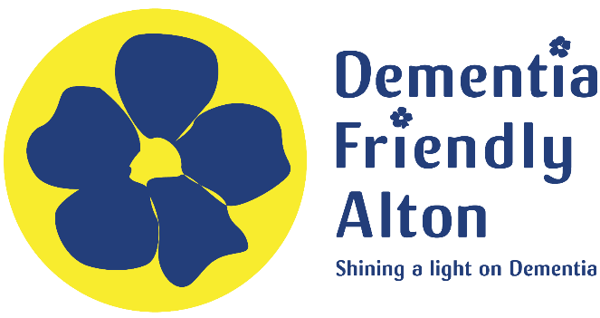

STAKEHOLDER INVITATION – 29th April 2026
AGENDA
Date: Wednesday 29th April 2026
Time: 1300-1530

1300 – 1345: Reception and Viewing of Postcard Exhibition (Light lunch provided)
1345 – 1415: Overview of the ‘Waiting Well’ study from the research team involved
1415 – 1515: Stakeholder discussion re the implications of findings for local dementia pathway
1515 – 1530: Opportunities for future practice and collaboration

Location: Alton Assembly Rooms, High Street, Alton, Hants., GU34 1BA
The Assembly Rooms is located on the High Street next to the Curtis Museum and War Memorial. There are just a few spaces to park on site, but many car parks (pay and display) within 2 mins walk – Map of local car parks



RSVP to karen.murrell@dementia-friendly-alton.org.uk by 27th April

